**University of engineering & technology Peshawar**



**Circuit & system-1**

**Lab report # 11&12**

**Fall 2020**

**Submitted by: Ashfaq Ahmad**

**Section: B**

**Reg No: 19PWCSE1795**

**Semester: 2nd**

**Student signature: ____________________**

**Submitted to:**

**Eng: faizullah**

**Department Of Computer System Engineering**

**ASSESSMENT RUBRICS LAB # 11 & 12**

**Thevenin’s and Norton’s theorem using PSpice**

|  |  |  |
| --- | --- | --- |
| **Criteria** | **Excellent** | **Marks Obtained** |
| 1. **Objectives of Lab** | All objectives of lab are properly covered  [Marks 0.5] |  |
| 1. **Thevenin and Norton’s Theorem** | Brief introduction to both the theorems and circuit diagrams and mention “ab” terminal points.  [Marks 1.5] |  |
| 1. **PSpice** | Brief introduction and steps for simulation  [Marks 2] |  |
| 1. **Observations and calculations** | Each step to obtain final result along with circuit diagrams  [Marks 5] |  |
| 1. **Conclusion** | Conclusion obtained from readings  [Marks 1] |  |

* 1. **Objectives:**
* To know about Norton and thevenin & Norton theorem.
* To know about PSPICE and its uses.
* To know how we verify these laws using PSPICE.
  1. **A) Thevenin’s theorem:**
* **Thevenin's Theorem** states that “Any linear circuit containing several voltages and resistances can be replaced by just one single voltage in series with a single resistance connected across the load“.
* Thevenin’s Theorem states that it is possible to simplify any linear circuit, no matter how complex, to an equivalent circuit with just a single voltage source and series resistance connected to a load

**B)Norton theorem:**

* Norton’s **Theorem** states that “Any linear circuit containing several energy sources and resistances can be replaced by a single Constant Current generator in parallel with a Single Resistor“.
* Norton’s Theorem states that it is possible to simplify any linear circuit, no matter how complex, to an equivalent circuit with just a single current source and parallel resistance connected to a load.
  1. **PSPICE:**
* *Spice*is a program developed by the EE Department at the University of California at Berkeley for computer simulation of analog circuits.  In its original form you tell Spice what elements are in the circuit (resistors, capacitors, etc.), and then enter the circuit diagram as an ASCII file showing what nodes each element is connected to.  Every node is assigned a number, and there is always a ground node, which is Number 0.  You then tell Spice what information you want -- bias conditions, frequency response, and/or transient response.  Spice does the circuit analysis and puts out an ASCII file with the information.

**We perform PSPICE schematics circuit simulation according to following steps:**

* Design your circuit in schematics. This can be divided into following sub steps.

**1).** First insert all the parts without considering their values (for example, place a resistor without considering the resistance value of it, etc.).

**2).** Make the necessary rotations for the parts, and move the parts to appropriate locations.

**3).** Make all the necessary wire connections.

**4).** Mark the nodes you are interested in with labels.

**5).** Set the values for all the parts, for example, the resistance values of resistors, the width (W) and length (L) of transistor, etc.

* Define the SPICE model for NMOS and PMOS transistors.
* Setup analysis to tell SPICE what simulation you need (transient analysis, DC sweep, etc.)
* Run the simulation.
* Observe the simulation results (traces of signals) in OrCAD PSpice A/D Demo.
  1. **Observation and calculation:**

Now we perform the experiment for verification of thevenin and Norton law by using psice.

Consider the following circuit for the verification of the theorem:

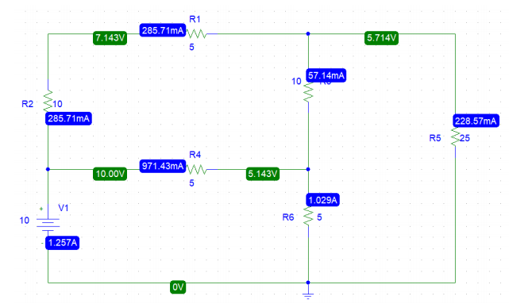

Circuit: 1

**Calculation no-1 for R6.**

To verify thevenin and Norton law we will need to perform the following three action;

* Remove the resistor R6 and leave the circuit open across R6.
* Remove the resistor R6 and join the wires across R6 to short the circuit.
* Find Rth (thevenin resistance).

**Step 1:** first we find thevenin resistance. According to ohm law thevenin resistance is given by,

**Rth =**

For finding **Rth** first we find  **and .**

=???

To find first we modify the circuit-1 by removing R6 and keeping the circuit open and then simulate I,e 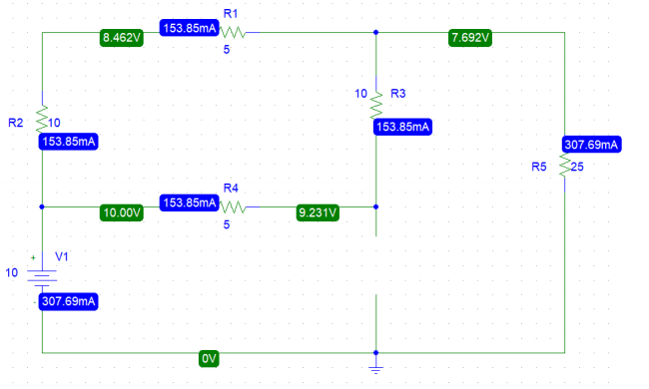

Thus the value of is given by;

VTH=9.231v

Isc =???

to find  **we have to further modify** the circuit by joining the wire across the R6 to short the circuit I,e

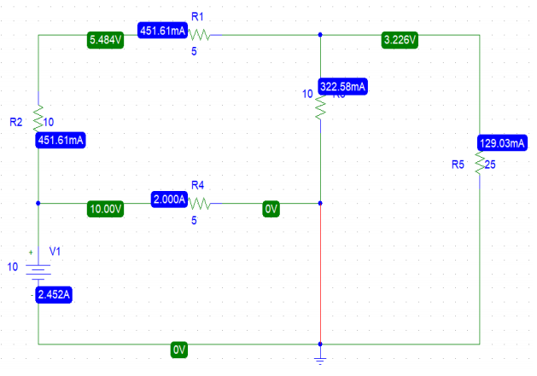

Now the current across R6 which is is,

=2.452A

Now we can find the Thevenin resistance using the give formula by putting value of and

**Rth =**

RTH= 9.231/ 2.452

RTH=3.767Ω

**Step 2:** now we find Norton current In .

We can find the Norton current by using given formula:

In = 𝑉𝑇ℎ/ RTH

In = 9.231 3.767

**Step 3: source transformation:**

By Using these values of Norton current (isc), Thevenin Resistance (RTH) & Thevenin voltage (VTH) we can perform source Transformation and can simplified the circuit-1 I,e

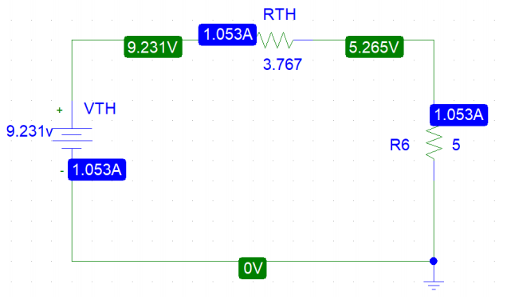

This circuit now represent the whole circuit given in the Figure 1.

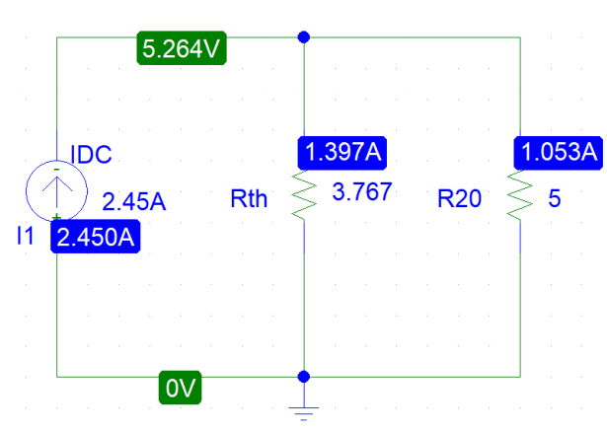

In the above circuit the resistor R20 has value of that of R6. This circuit now represent the whole circuit given in the Figure 1.

**Calculation no-2 for R2.**

Consider the following circuit for the verification of the theorem:



Circuit: 1

To verify thevenin and Norton law we will need to perform the following three action;

* Remove the resistor R2 and leave the circuit open across R2.
* Remove the resistor R2 and join the wires across R6 to short the circuit.
* Find Rth (thevenin resistance).

**Step 1:** first we find thevenin resistance. According to ohm law thevenin resistance is given by,

**Rth =**

For finding **Rth** first we find  **and .**

=???

To find first we modify the circuit-1 by removing R2 and keeping the circuit open and then simulate I,e

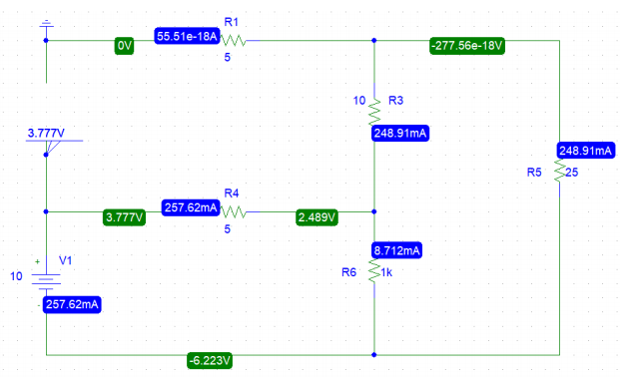

Thus the value of is given by;

VTH= 3.777 v

Isc =???

To find **we have to further modify** the circuit by joining the wire across the R2 to short the circuit I,e

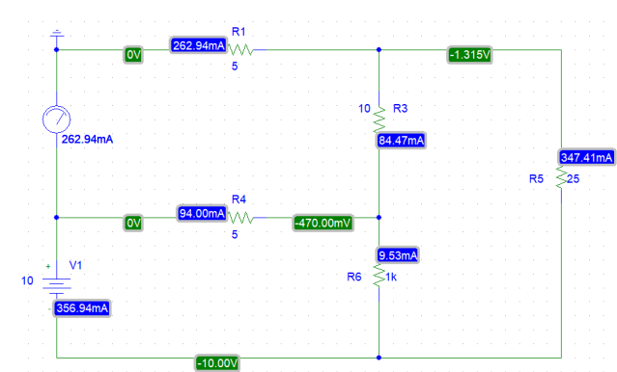

Now the current across R6 which is is,

= 262.94mA

Now we can find the Thevenin resistance using the give formula by putting value of and

**Rth =**

RTH= 3.777/ 262.94

RTH = 14.3645Ω

**Step 2:** now we find Norton current In .

We can find the Norton current by using given formula:

In = 𝑉𝑇ℎ/ RTH

In = 3.777/ 14.3645

In = 262.94mA

**Step 3:** **source transformation:**

By Using these values of Norton current (isc), Thevenin Resistance (RTH) & Thevenin voltage (VTH) we can perform source Transformation and can simplified the circuit-1 I,e

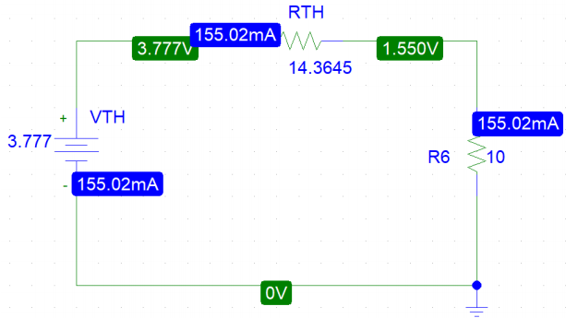

This circuit now represent the whole circuit given in the Figure 1.

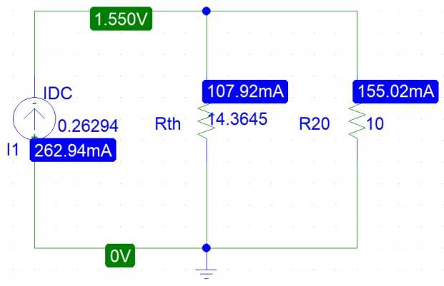

In the above circuit the resistor R20 has value of that of R2. This circuit now represent the whole circuit given in the Figure 1.

**Calculation no-3 for R5.**

Consider the following circuit for the verification of the theorem:



Circuit: 1

To verify thevenin and Norton law we will need to perform the following three action;

* Remove the resistor R5 and leave the circuit open across R5.
* Remove the resistor R5 and join the wires across R6 to short the circuit.
* Find Rth (thevenin resistance).

**Step 1:** first we find thevenin resistance. According to ohm law thevenin resistance is given by,

**Rth =**

For finding **Rth** first we find  **and .**

=???

To find first we modify the circuit-1 by removing R5 and keeping the circuit open and then simulate I,e

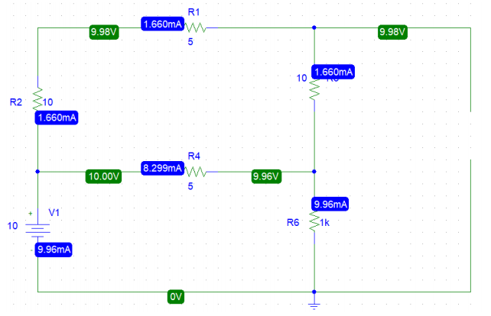

Thus the value of is given by;

VTH= 9.98v

Isc =???

To find **we have to further modify** the circuit by joining the wire across the R5 to short the circuit I,e

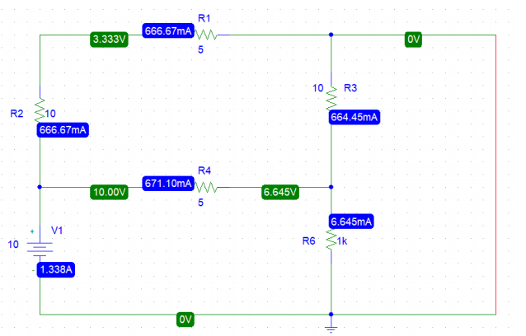

Now the current across R6 which is is,

= =1.338A

Now we can find the Thevenin resistance using the give formula by putting value of and

**Rth =**

RTH= 9.98/ 1.338

RTH=7.459Ω

**Step 2:** now we find Norton current In .

We can find the Norton current by using given formula:

In = 𝑉𝑇ℎ/ RTH

In = 9.98 /7.459

In = 1.338A

**Step 3: source transformation:**

By Using these values of Norton current (isc), Thevenin Resistance (RTH) & Thevenin voltage (VTH) we can perform source Transformation and can simplified the circuit-1 I,e

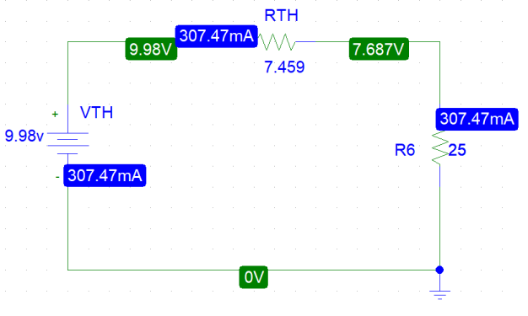

This circuit now represent the whole circuit given in the Figure 1.

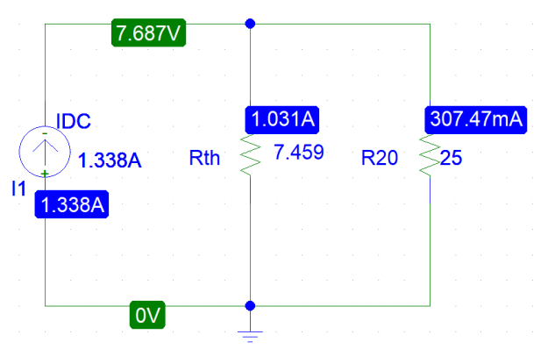

In the above circuit the resistor R20 has value of that of R5. This circuit now represent the whole circuit given in the Figure 1.

**Calculation no-4 for R3.**

Consider the following circuit for the verification of the theorem:



Circuit: 1

To verify thevenin and Norton law we will need to perform the following three action;

* Remove the resistor R3 and leave the circuit open across R3.
* Remove the resistor R3 and join the wires across R3 to short the circuit.
* Find Rth (thevenin resistance).

**Step 1:** first we find thevenin resistance. According to ohm law thevenin resistance is given by,

**Rth =**

For finding **Rth** first we find  **and .**

=???

To find first we modify the circuit-1 by removing R5 and keeping the circuit open and then simulate I,e

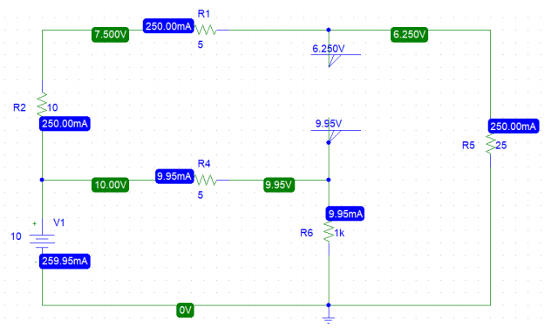

Thus the value of is given by;

VTH= 9.95 – 6.250 = 3.7 v

Isc =???

To find **we have to further modify** the circuit by joining the wire across the R3 to short the circuit I,e

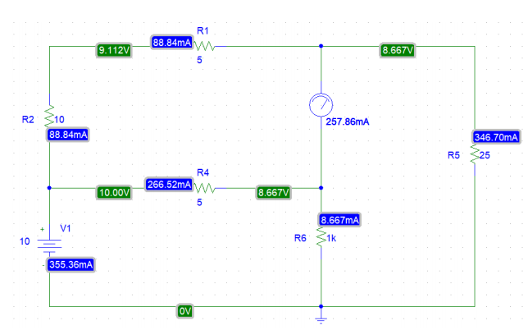

Now the current across R3 which is is,

= 257.86mA

Now we can find the Thevenin resistance using the give formula by putting value of and

**Rth =**

RTH= 3.7/ 0.25786

RTH=14.345Ω

**Step 2:** now we find Norton current In .

We can find the Norton current by using given formula:

In = 𝑉𝑇ℎ/ RTH

In =3.7/14.345

In = 257.86mA

**Step 3: source transformation:**

By Using these values of Norton current (isc), Thevenin Resistance (RTH) & Thevenin voltage (VTH) we can perform source Transformation and can simplified the circuit-1 I,e

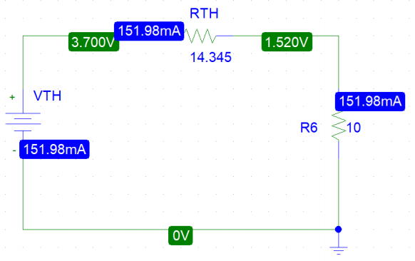

This circuit now represent the whole circuit given in the Figure 1.

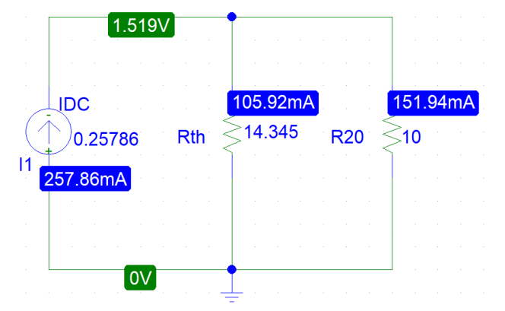

In the above circuit the resistor R20 has value of that of R3. This circuit now represent the whole circuit given in the Figure 1.

**Calculation no-5 for R4.**

Consider the following circuit for the verification of the theorem:



Circuit: 1

To verify thevenin and Norton law we will need to perform the following three action;

* Remove the resistor R4 and leave the circuit open across R4.
* Remove the resistor R4 and join the wires across R3 to short the circuit.
* Find Rth (thevenin resistance).

**Step 1:** first we find thevenin resistance. According to ohm law thevenin resistance is given by,

**Rth =**

For finding **Rth** first we find  **and .**

=???

To find first we modify the circuit-1 by removing R4 and keeping the circuit open and then simulate I,e

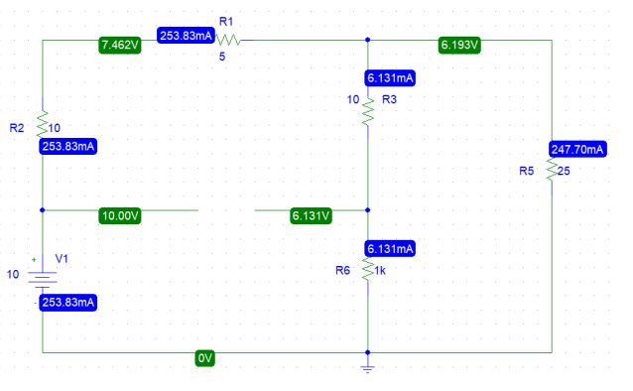

Thus the value of is given by;

VTH= 6.131v

Isc =???

To find **we have to further modify** the circuit by joining the wire across the R4 to short the circuit I,e

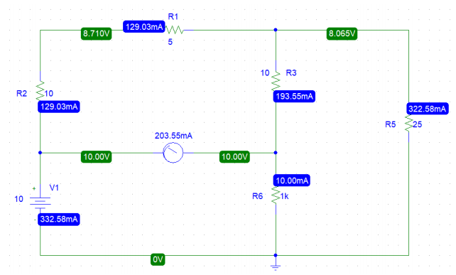

Now the current across R3 which is is,

= 203.55mA

Now we can find the Thevenin resistance using the give formula by putting value of and

**Rth =**

RTH= 6.13/ 203.55

RTH=30.12 Ω

**Step 2:** now we find Norton current In .

We can find the Norton current by using given formula:

In = 𝑉𝑇ℎ/ RTH

In =6.13/30.12

In = 0.20355A

**Step 3: source transformation:**

By Using these values of Norton current (isc), Thevenin Resistance (RTH) & Thevenin voltage (VTH) we can perform source Transformation and can simplified the circuit-1 I,e

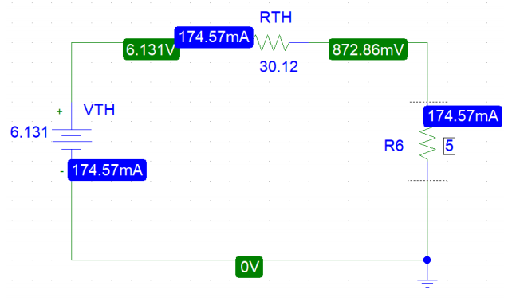

This circuit now represent the whole circuit given in the Figure 1.

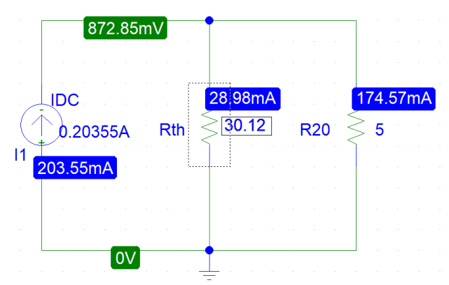

In the above circuit the resistor R20 has value of that of R4. This circuit now represent the whole circuit given in the Figure 1.

**The end**